**MSE 4401A: Robotic Manipulators – 2018 Assignment #4**

Jianhui li

250843421

**Procedure:**

1)  Create three MATLAB functions for the forward kinematics, the inverse kinematics and the Jacobian of RPR joints of the manipulator T = fkinRPR(q), q = invkinRPR(T), and J = JacobRPR(q). This code has modified, so that the fkinRPR and JacobRPR can return the intermediate Jv and T. In the invkinRPR function, it can return two set of joint parameters. I keep the positive set to use as a return.

2) The obstacles are in positions [0,0,25]; [-10,-10,30]; [20,30,10].

Because the manipulator is RPR, so it cannot reach every point in a cylinder space. In the second picture, it is clear that the workspace is like a big “M”, and rotate it to get the workspace. The manipulator can reach every point around the three obstacles.

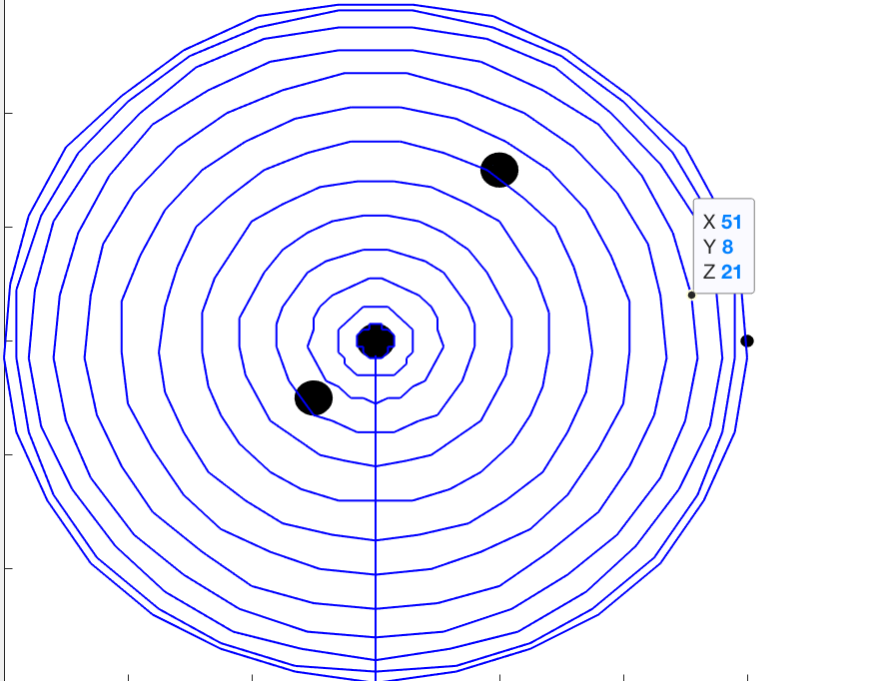 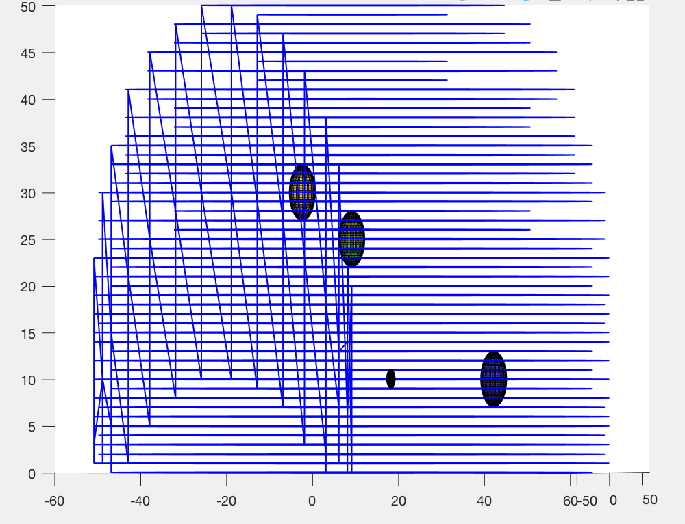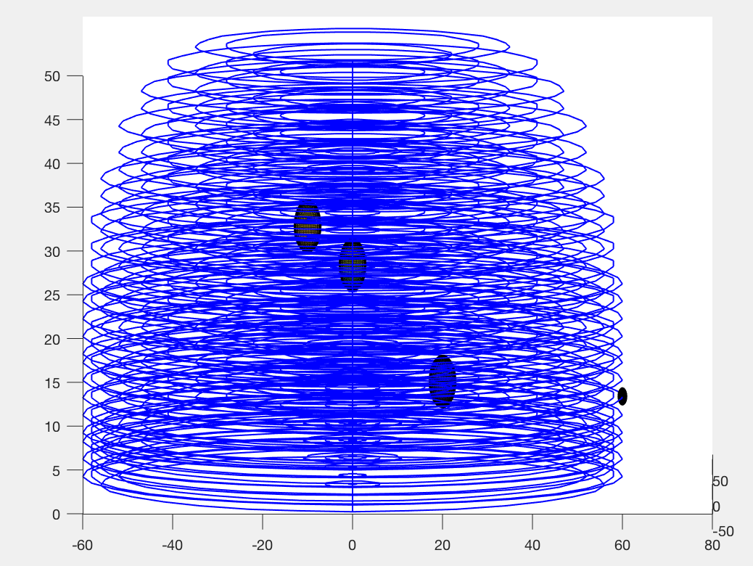

3)  In the path algorithm, the first step is the repulsive and attractive forces on each joint. In this manipulator, it has three joints. So the total torque needs to summary three group of forces. Besides, there are three obstacles in the workspace, therefore, the repulsive force on each joints has three parts for each obstacle. Besides, when to find the shortest distance and point, I create a calculation to get the point position. Because all the obstacle is set to be sphere, therefore, we can know the shortest point on each obstacle. Then, calculate the total joint torques, and use the algorithm to get the path.

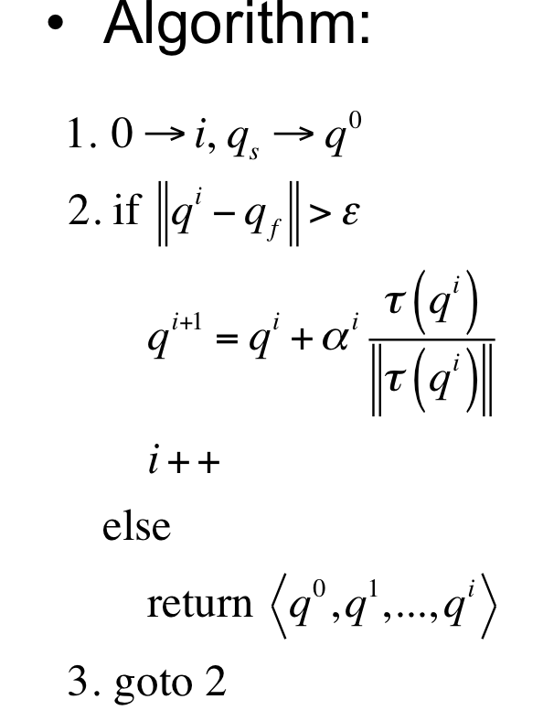

|  |
| --- |
| % calculate theta 1 2      % they are for different obstacle      th11= atan2(z01, sqrt(x01^2+y01^2));      th12=atan2(y01,x01);      th21= atan2(z02, sqrt(x02^2+y02^2));      th22=atan2(y02,x02);      th31= atan2(z03, sqrt(x03^2+y03^2));      th32=atan2(y03,x03);                z11=r*sin(th11);          y11=r*cos(th11)*sin(th12);          x11=r*cos(th11)*cos(th12)-25;              z21=r*sin(th21)+10;          y21=r*cos(th21)*sin(th22)+10;          x21=r*cos(th21)*cos(th22)-30;            z31=r*sin(th31)-20;          y31=r*cos(th31)*sin(th32)-30;          x31=r*cos(th31)*cos(th32)-10;          %b is the colsest point on the obstacle      b{i}(:,1)=[x11;y11;z11];      b{i}(:,2)=[x21;y21;z21];      b{i}(:,3)=[x31;y31;z31]; |
|  |
|  |

**Question & Answer:**

a)  Select two different start and end positions of your choice and show that the obstacle avoidance works. These positions must be chosen such that a straight-line path would collide with at least one obstacle. Include figures that show the results of the path planning. **[20 points]**

Answer:

1. starting position: [x, y, z] = [40 0 10] ending point: [x, y, z] = [-30 0 35]

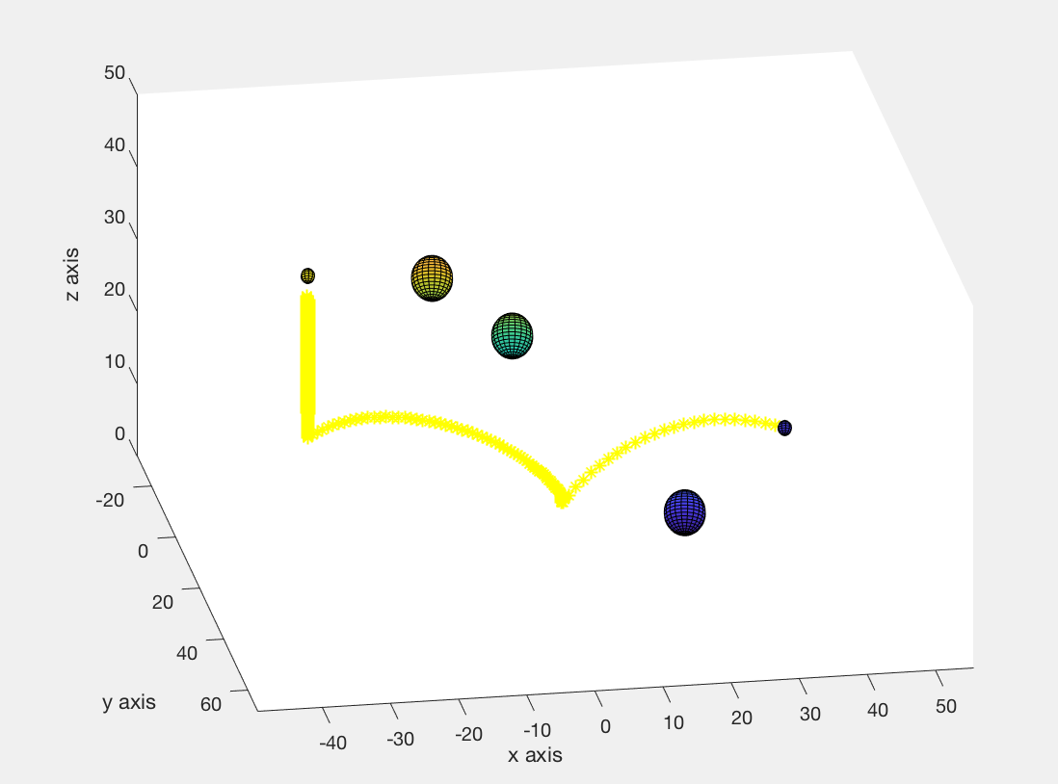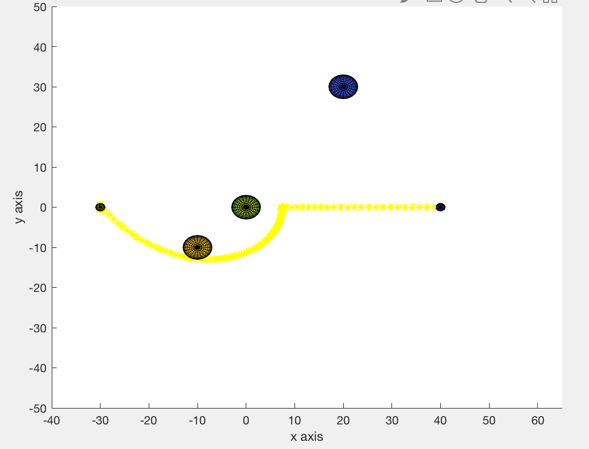

2. starting position: [x, y, z] = [60 0 5] ending point: [x, y, z] = [-20 0 30]

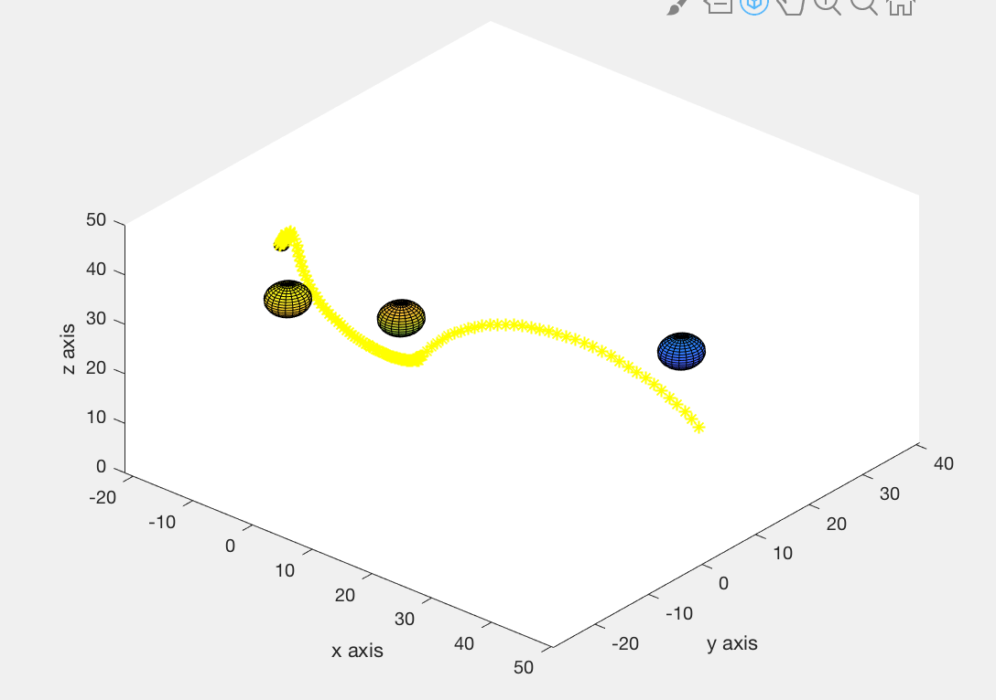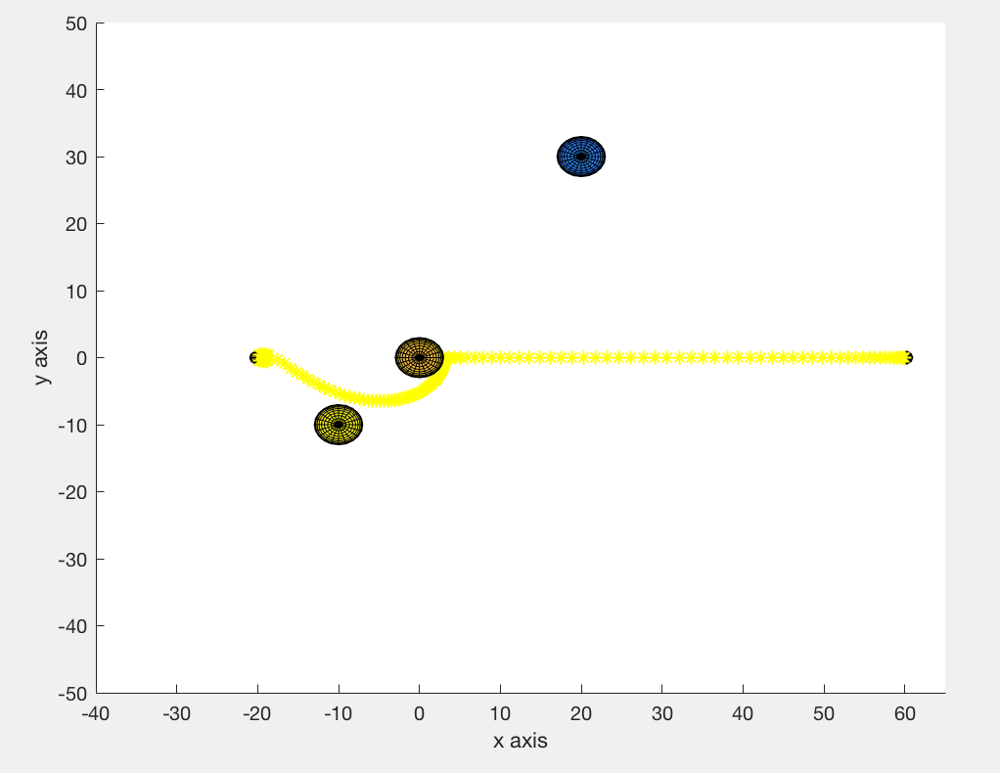

b)  For one particular start and end position of your choice, vary the range for the repulsive fields for some of the obstacles (at least two different values). Show the results of this variation. Explain and discuss what is happening. **[15 points]**

Answer:

The demonstration uses starting position: [x, y, z] = [60 0 5] ending point: [x, y, z] = [-20 0 30].

When the range of repulsive field is ρ0 = 1, the graph shows in the picture below. The end effector of manipulator goes through the middle of two obstacles in the bottom of picture.



When the range of repulsive field is ρ0 = 10, the graph shows in the picture below. The end effector of manipulator goes through from top of two obstacles compared to when ρ0 = 1.

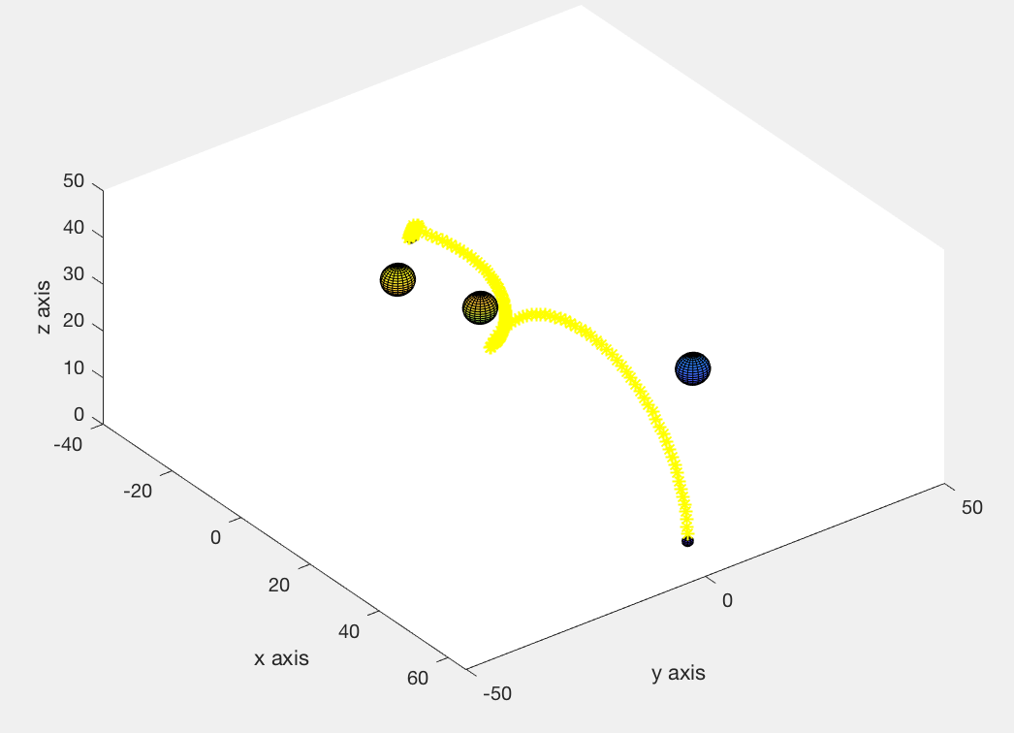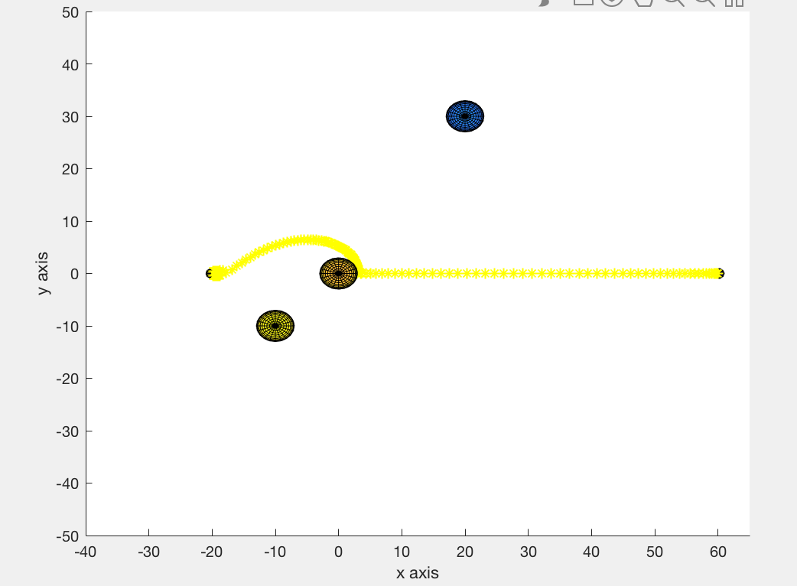

This variation is obvious. When the range of repulsive field increase, the area of potential field around obstacles also increase. It will influence the manipulator goes to anther path to avoid the high potential field area. The high potential field area is similarly like a huge mountain which cut the path. Therefore, when ρ0 = 1, the potential field in the middle of two bottom obstacles is smaller than that of ρ0 = 10. So when ρ0 =10, the repulsive force of two bottom obstacles push the end effector to another empty space.

c)  For one particular start and end position of your choice, vary the attractive and repulsive field constants (at least two different values for each). Show the results of this variation. Explain and discuss what is happening. **[15 points]**

Answer:

The demonstration uses starting position: [x, y, z] = [60 0 40] and ending point: [x, y, z] = [-20 -20 30].

When the parabolic well potential constant (attractive field constant) is equal to 10 and repulsive field constant is 1, the picture shows on the left side. The path is all shown in the graph. When the parabolic well potential constant (attractive field constant) is equal to 1 and repulsive field constant is 10, the path has a greater radius and cannot be shown within the graph. These two graph have the same size. Therefore, when the repulsive force increases and attractive force decrease, the path is farther away from each obstacle, which makes sense due to the greater repulsive filed.

